NDNY FEDERAL COURT BAR ASSOCIATION, INC.  www.ndnyfcba.org | 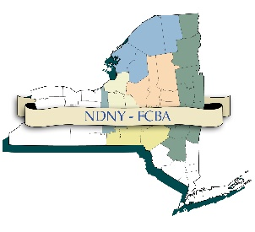
NOTICE OF CLE PROGRAM
The NDNY-FCBA’s CLE Committee
Presents

“The Supreme Court’s decision in Alston v. NCAA, and its ramifications for college sports”

Thursday, December 9, 2021
1:30 p.m. – 2:45 p.m.
(Registration at 12:30 p.m.)
(R.S.V.P. by December 1, 2021)

Craftsman Inn
Syracuse, New York

This program will discuss the Supreme Court’s reasoning and holding in Alston v. NCAA, wherein the Supreme Court unanimously held that the NCAA could not enforce certain rules limiting the education-related benefits that colleges offer their athletes. Under Alston, colleges can begin immediately offering incentives other than tuition to athletes, including computers, graduate scholarships, tutoring, and up to $5,900 in cash for academic awards.

Presenter:

John Wolohan, Esq.
Professor of Sports Law
David B. Falk College of Sport and Human Dynamics
Syracuse University

John Wolohan, Professor of Sports Law, Syracuse University, Syracuse, New York, USA
Attorney John Wolohan (jwolohan@syr.edu) is a professor of Sports Law in the Syracuse University Sport Management program and an Adjunct Professor in the Syracuse University College of Law. Professor Wolohan has been teaching and working in the fields of sports law, gaming law, and sports media for over 25 years.
Professor Wolohan, who is a member of the Massachusetts Bar Association, received his J.D. from Western New England University, School of Law. Wolohan also has a B.A. from the University of Massachusetts - Amherst and M.A. from Syracuse University
.

Agenda

1:30-1:45 Introduction and Welcome
(Daniel Rubin, Esq.)

1:45-2:45 Presentation, Questions and Closing

The Northern District of New York Federal Court Bar Association
has been certified by the New York State Continuing Legal Education Board
as an Accredited Provider of continuing legal education in the State of New York.
“The Supreme Court’s decision in Alston v. NCAA, and its ramifications for college sports”
has been approved in accordance with the requirements of
the New York State Continuing Legal Education Board for
1.5 credit towards the Skills requirement.*

This program is appropriate for newly admitted and experienced attorneys.

This is a single program. No partial credit will be awarded.

This program is complimentary to all Northern District of New York
Federal Court Bar Association Members.

